PRACTICAL - 7
AIM: Consider a software development project with the following activities:
Activity A: Define Requirements (Duration: 5 days)
Activity B: Design Database (Duration: 8 days)
Activity C: Develop Frontend (Duration: 10 days)
Activity D: Implement Backend (Duration: 12 days)
Activity E: Perform Testing (Duration: 6 days)
Activity F: Deployment (Duration: 8 days)
1. Use the information to construct a Precedence Diagram.
2. Calculate Early Start (ES), Early Finish (EF), Late Start (LS), Late Finish (LF), and Total Float for each activity.
3. Determine the Critical Path.
4. Calculate the total project duration.
Solution:
Team Details:
Sr. No. | Name | Enrollment No.
Team Leader | Sarth Chaudhari | 202303103510106
Team Member 1 | Yash Patel | 202203103510228
Team Member 2 | Gati Shah | 202203103510261
Team Member 3 | Fenil Shilodre | 202203103510041
Team Member 4 | Angat Shah | 202203103510097

Introduction

Project scheduling is a fundamental aspect of software project management, ensuring tasks are completed efficiently within defined timeframes.

The Critical Path Method (CPM) is used to estimate the total project duration and identify activities crucial to timely completion. This involves analyzing project activities, calculating scheduling parameters like Early Start (ES), Early Finish (EF), Late Start (LS), Late Finish (LF) and Total Float. By determining these values, we can accurately schedule the tasks, identify the critical path and ensure the project is completed within the required timeframe.

Project Title : Airbnb System

Project Activities and Dependencies
Activity | Description | Duration (Weeks) | Predecessors
A | Requirement Analysis | 5 | -
B | UI/UX Design | 8 | A
C | Backend Development | 10 | -
D | Frontend Development | 12 | B
E | Payment Gateway Integration | 6 | C
F | Testing | 8 | D, E
G | Deployment | 4 | F

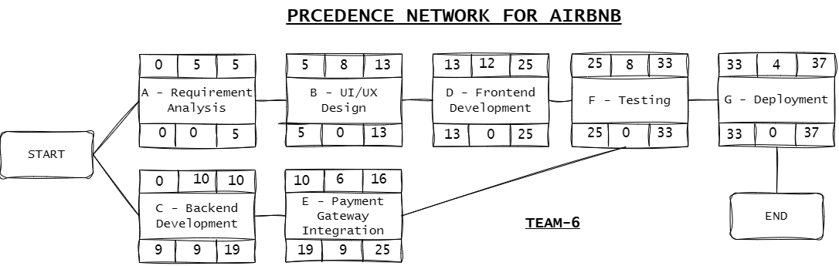

CPM Calculation :
Activity | ES | EF | LS | LF | Total Float
A | 0 | 5 | 0 | 5 | 0
B | 5 | 13 | 5 | 13 | 0
C | 0 | 10 | 9 | 19 | 9
D | 13 | 25 | 13 | 25 | 0
E | 10 | 16 | 19 | 25 | 9
F | 25 | 33 | 25 | 33 | 0
G | 33 | 37 | 33 | 37 | 0

Critical Path & Project Duration :

The Critical Path : A → B → D → F → G

The Total Project Duration : 37 Weeks

Project Title : Farfetch E-commerce System

Project Activities and Dependencies
Activity | Description | Duration (Weeks) | Predecessors
A | Requirement Analysis | 6 | -
B | Product Catalog Design | 7 | A
C | Recommendation Engine Development | 14 | -
D | Payment Gateway Integration | 10 | -
E | UI/UX Design | 8 | A
F | Frontend & Backend Development | 18 | B, C, E
G | Testing | 12 | D, F
H | Deployment | 5 | G

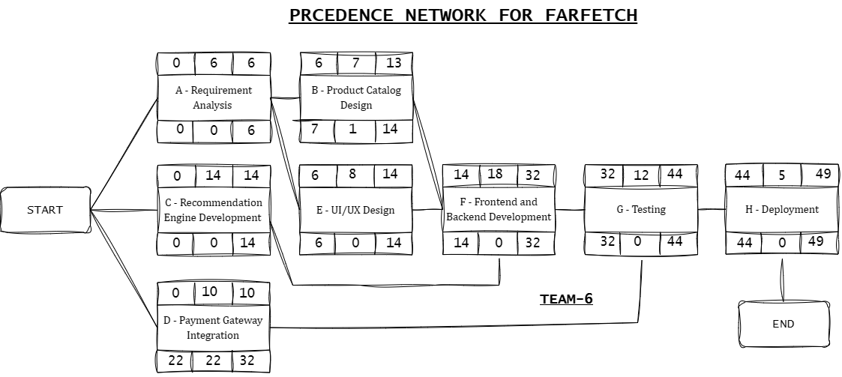

CPM Calculation :
Activity | ES | EF | LS | LF | Total Float
A | 0 | 6 | 0 | 6 | 0
B | 6 | 13 | 7 | 14 | 1
C | 0 | 14 | 0 | 14 | 0
D | 0 | 10 | 22 | 32 | 22
E | 6 | 14 | 6 | 14 | 0
F | 14 | 32 | 14 | 32 | 0
G | 32 | 44 | 32 | 44 | 0
H | 44 | 49 | 44 | 49 | 0

Critical Path & Project Duration :

The Critical Path : A → E → F → G → H

The Total Project Duration : 49 Weeks

Conclusion

CPM effectively determines project scheduling and helps identify critical tasks that require close monitoring.
- Farfetch requires a longer duration (49 weeks) due to its complexity, multiple integrations and parallel dependencies, while Airbnb’s timeline is shorter (37 weeks) with a more linear critical path.
- Both projects benefit from the flexibility provided by float values in non-critical tasks, allowing schedule adjustments without affecting the critical path.
- Backend development is a significant factor in both projects, and optimizing it could reduce delays.
- Testing and deployment are crucial for both projects, emphasizing their importance in real-world software releases.

